***Part 2:***

Form 1 asks the user to enter username and password. The code is very similar to task1. If the user pressed Login, the program searched in the dictionary if the username and password are saved as a pair. If they are not found, form 2 is shown and it has a Welcome text and a Log out button which closes form 2 and shows form 1. If username and password were not found, an error message is displayed.

If the user presses Register, form 3 is shown and asks the user to enter a new username and password. If the username already exists, an error message is displayed. After successfully registering, form 3 closes and form 1 is shown.

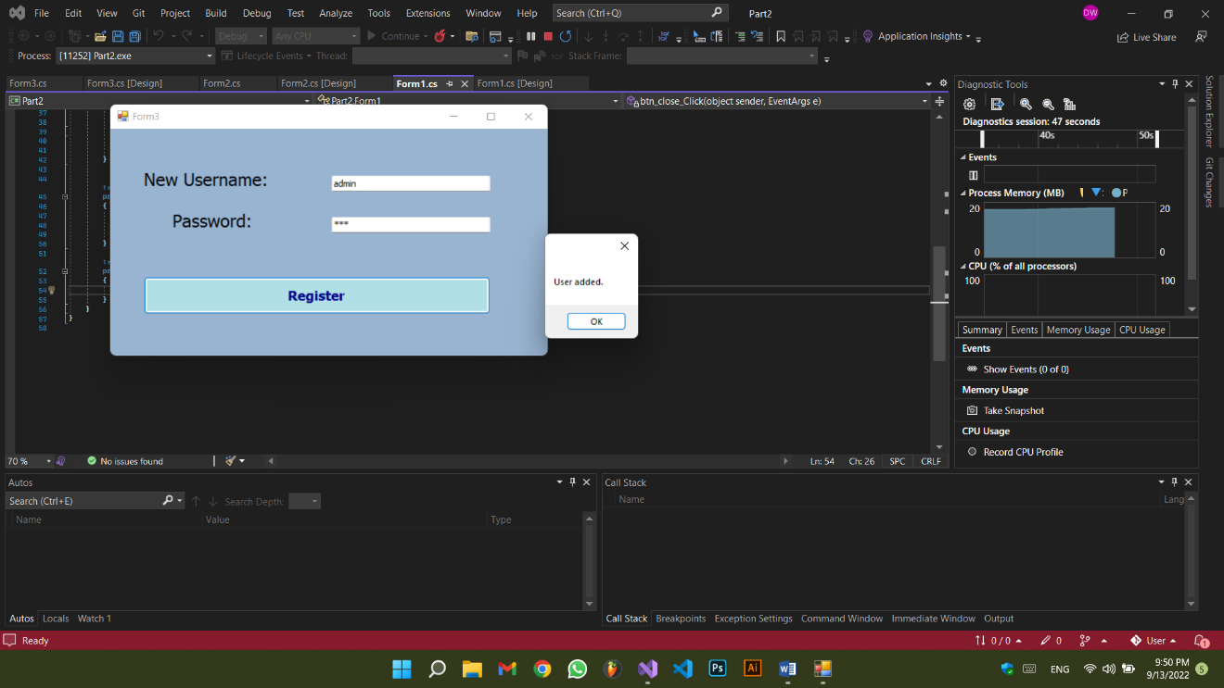

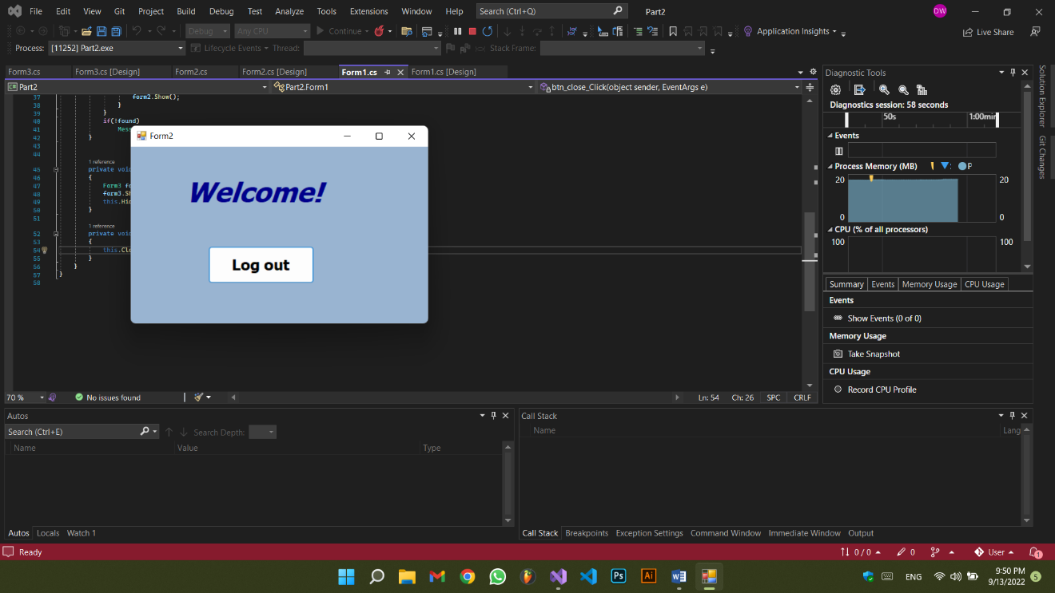

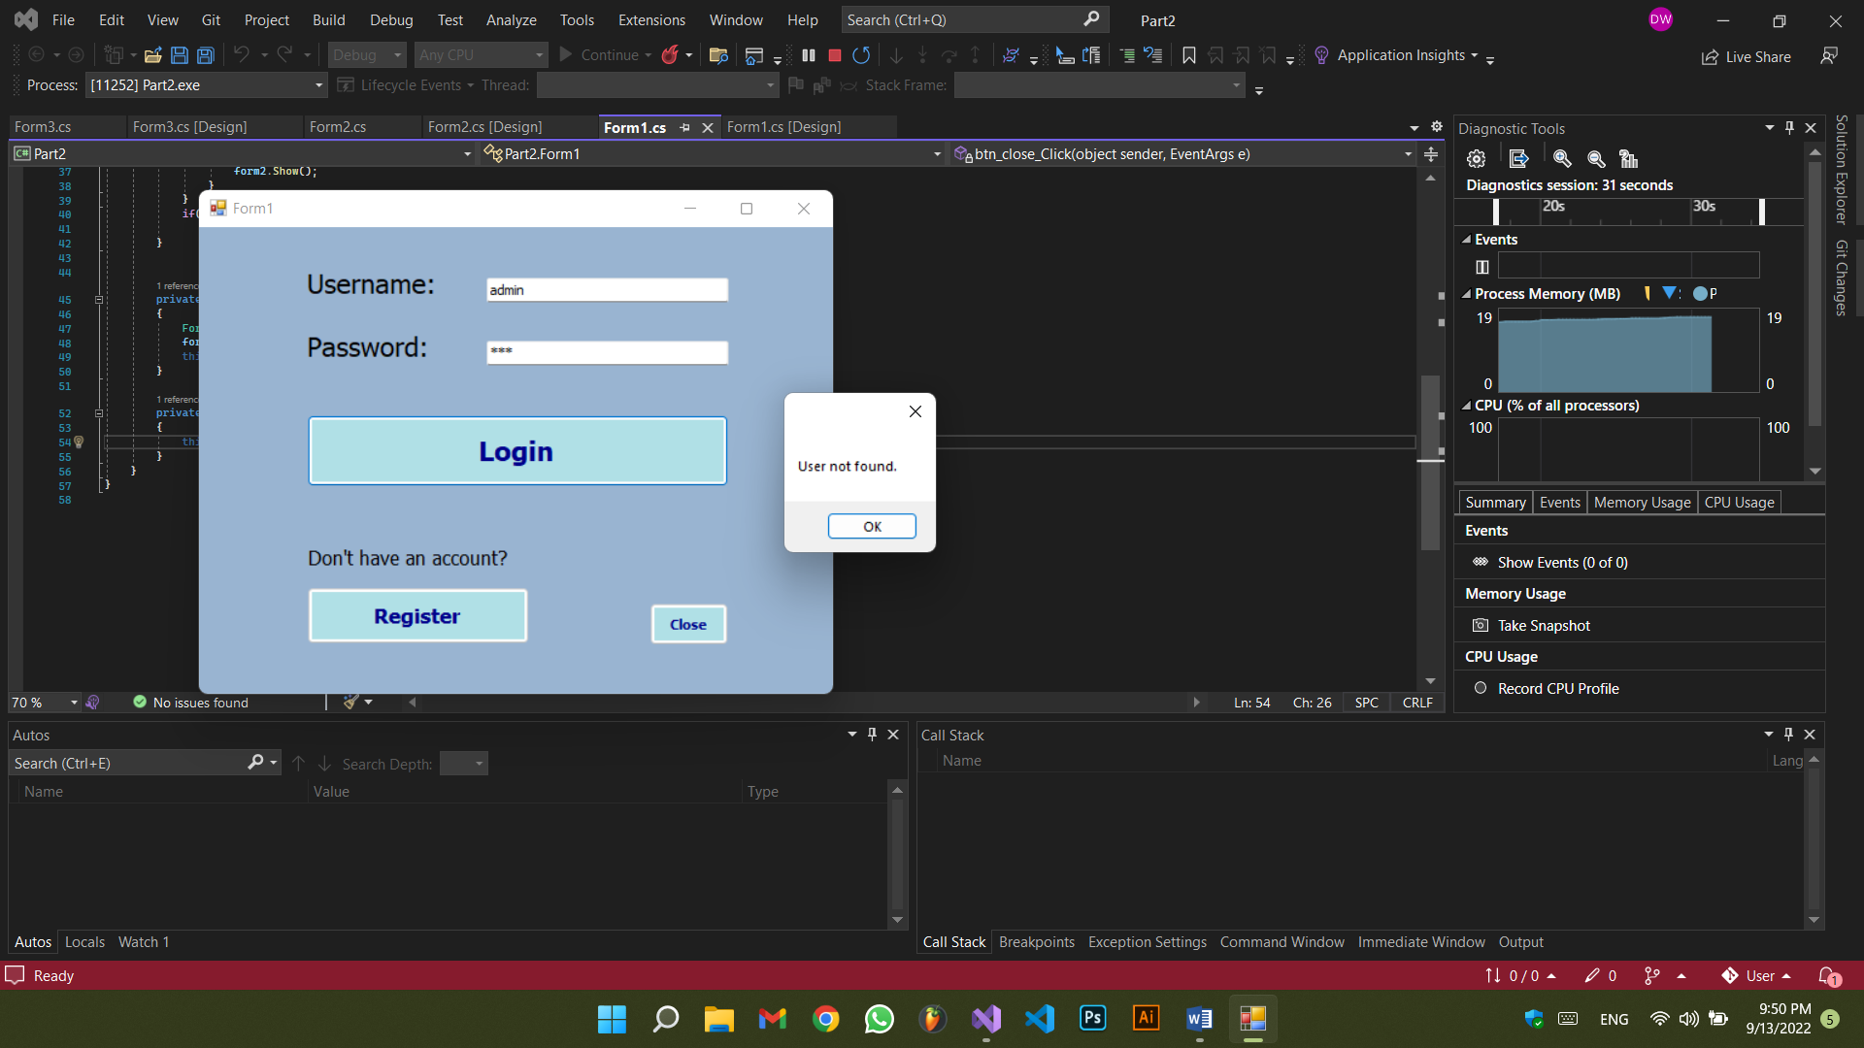

Form 1:

using System;

using System.Collections.Generic;

using System.Windows.Forms;

namespace Part2

{

public partial class Form1 : Form

{

public static Dictionary<string, string> dict = new Dictionary<string, string>();

public Form1()

{

InitializeComponent();

}

private void btn_login_Click(object sender, EventArgs e)

{

login(ref dict);

}

public void login(ref Dictionary<string, string> dict)

{

bool found = false;

foreach (KeyValuePair<string, string> pair in dict)

{

if (pair.Key == tb_username.Text && pair.Value == tb_password.Text)

{

found = true;

Form2 form2 = new Form2();

this.Hide();

form2.Show();

}

}

if(!found)

MessageBox.Show("User not found.");

}

private void btn_register_Click(object sender, EventArgs e)

{

Form3 form3 = new Form3();

form3.Show();

this.Hide();

}

private void btn_close_Click(object sender, EventArgs e)

{

this.Close();

}

}

}

Form 2:

using System;

using System.Windows.Forms;

namespace Part2

{

public partial class Form2 : Form

{

public Form2()

{

InitializeComponent();

}

private void button1_Click(object sender, EventArgs e)

{

Form1 form1 = new Form1();

form1.Show();

this.Close();

}

}

}

Form 3:

using System;

using System.Collections.Generic;

using System.Windows.Forms;

namespace Part2

{

public partial class Form3 : Form

{

public Form3()

{

InitializeComponent();

}

Form1 form1 = new Form1();

private void btn_register_Click(object sender, EventArgs e)

{

registerPair();

}

void registerPair()

{

bool search = false;

foreach (KeyValuePair<string, string> pair in Form1.dict)

{

if (pair.Key == tb_username.Text)

{

search = true;

MessageBox.Show("User already exists.");

form1.Show();

this.Close();

}

}

if (search == false)

{

Form1.dict.Add(tb_username.Text, tb_password.Text);

MessageBox.Show("User added.");

form1.Show();

this.Close();

}

}

}

}